Professional ministry families need to experience a significant degree of support to maintain spiritual and emotional vitality. Southeastern California Conference offers anonymous counseling service to provide care for pastor and office employees and their families.

How the Program Works

- All pastors, teachers and office employees of Southeastern California Conference, his/her spouse and immediate family members are eligible to receive six hours of professional counseling anonymously from the counselors listed on these pages.

- The employee and/or family member will initiate the appointment with the counselor and at each session will make a co-payment of $20.00 directly to the counselor. One of the coupons issued with this packet must also be presented to the counselor at each visit along with picture identification. The counselor will bill the remaining cost to the conference using the coupons and a number issued by counselor, thus preserving the anonymity of the client.

- If a counselor charges a fee for missed appointments without prior notification, the full amount should be paid by the employee or family member.

The anonymous counseling program is not the same as an insurance program. Only the counselors listed here have contracted to provide their services for a substantially discounted rate. Do not consult with counselors not listed here unless you arrange to pay for it yourself or go through your medical plan. There may be an unusual circumstance in which other counselors not listed may be needed, but they must be approved first. Questions may be directed to the Human Resources Department office of Southeastern California Conference. Callers may remain anonymous.

Please be advised that the most current list of counselors that work with this program will be available on the HR Website at secchr.adventistfaith.org

Ronald Bacon, M.A., M.Div.
Licensed marriage and family therapist SDA pastoral ministry experience.
31952 Camino Capistrano #C-23
San Juan Capistrano, CA 92675 949.488.8990

Lori A. Barker, Ph.D.
Clinical psychologist, working with families and mood disorders. She has special skills in multicultural issues.
IFC Wellness Center
7177 Brockton Ave, Suite 226
Riverside, CA 92506 909.539.8955

Antonius Brandon, Ph.D.
Licensed psychologist, marriage and family counselor. Pastoral ministry experience. Marital and individual therapy, pain management and biofeedback.
Riverside Psychiatric Medical Group
5887 Brockton Avenue, Suite A
Riverside, CA 92506 951.275.8500

Christian Counseling Center
The Christian Counseling Center therapists participate in the anonymous counseling program. There is a full list of therapists and specialties attached.

Robert C. Connerly, Ph.D.
Dr. Connerly is a clinical psychologist formerly with Pathways Counseling. His specialty is in improving relationships, spiritual crisis and depression. He also is a child custody evaluator and is an expert in family violence issues.
7177 Brockton Avenue Suite 331
Riverside, CA 92506 951.788.8810

Karyl L. Dupee, M.A.
Licensed marriage, family and child counselor.
1651 E. 4th St., Suite 138
Santa Ana, CA 92701 714.490.7058

David Ferreira, M.A.
Licensed marriage and family therapist and clinical psychologist, Specializes in counseling adolescents and families. Experienced Baptist youth pastor.
205 West 5th Avenue, Suite 201
Escondido, CA 92025 760.489.0598

Wm. Brad Graff, M.S., MTF
Licensed marriage and family therapist working with individuals, couples, families, children and teens. Special experience with trauma, family violence, divorce recovery and issues of adolescence. Very familiar with couples counseling, affair recovery and porn addiction.
Helix Counseling Associates
4215 Spring Street, #210
La Mesa, CA 91941 619.589.8971

Valinda L. Greene, Ph.D.
Licensed clinical psychologist. Family and child counseling specializing in behavioral and family systems in a Christian setting.
5360 Jackson Dr., Suite 112
La Mesa, CA 91942 619.697.0934

Janet Hackleman, M.S.
Licensed marriage and family therapist with specialty in parent/child conflicts. Frequent lecturer at Loma Linda University and parenting seminars.
22737 Barton Road, Suite 5
Grand Terrace, CA 92313 909.370.4250

Tammy Hilliard, M.S., LPCC
Bilingual. Works with adults, couples & teens. Specializes in anxiety, depression, grief, phase of life, trauma survivors and couples’ work.
47 1st St. tammy.hilliard.lpcc@gmail.com
Redlands, CA 92373 909-488-8848

Gary Hittle, Ph.D.
Licensed psychologist and marriage and family therapist specializing in marriage/family therapy, depression, and adolescent therapy. Offices both in San Diego and El Centro.
5480 Baltimore Drive, Suite 202
La Mesa, CA 91942 619.464.7771

Karen Jacobs, M.S.
Licensed marriage and family therapist with experience in religious setting. Affiliated with Associated Therapists of Riverside.
3400 Central Avenue #310
Riverside, CA 92506 951.781.9004

Henry Lamberton, PsyD, MDiv
Experiences include pastoral ministry, faculty member in college/university departments of religion and dean of students in a medical school. Works with adults and couples. Areas of focus include anxiety, mood disorders, adjustment, grief, phases of life, relationships, spiritual concerns.
47 1st St. Henry.Lamberton.PsyD@gmail.com
Redlands, CA 92373 909.907.4549

Anne Janda, M.S.W.
Licensed marriage and family therapist and licensed clinical social worker. Extensive experience in individual and family counseling, divorce mediation and crisis intervention.
5945 Caminito de la Taza
San Diego, CA 92120 619.229.0590

Beverly Johnson, M.S., MFT
A marriage and family therapist with special interest in working with children, especially ADD, panic disorders and depression.
3576 Arlington Avenue, Suite 307
Riverside, CA 92506 951.784.4357

Jerold R. Kuhn, Ph.D.
Psychologist with interest in couple counseling and individual counseling for depression, stress and other life situations. Has served on the counseling staff at Crystal Cathedral.
285 E. Imperial, #206
Fullerton, CA 92635 714.879.7670

John E. Martin, Ph.D.
Licensed clinical psychologist with wide experience working with pastors and their families. Professor of Clinical Psychology at Fuller Seminary’s Graduate School of Psychology.
3020 Old Ranch Parkway, Suite 300
Seal Beach, CA 90740 877.651.3370

Paula May, Ph.D.
Licensed psychologist with specialty in couple’s counseling and substance abuse.
242 W. Main Street, Suite 200B
Tustin, CA 82780 949.600.5231

Douglas McKown, Ph.D.
Dr. McKown is director of Samaritan Counseling Center with a full staff of counselors covering a wide spectrum of therapeutic issues, marriage and family, mood disorders, grief and loss, and trauma.
Samaritan Counseling Center
1126 W. Foothill, #1111
Upland, CA 91786 909.985.0513

Dan Nyirady, LMFT
Licensed marriage and family therapist specializing in couples counseling and individuals 16+ years old, anxiety, depression, grief and loss, life transitions. Office online and in Riverside.
4500 Riverwalk Parkway
Riverside, CA 92505 951.386.0843

Sarah Oh, LMFT
Sozo Family Counseling
Specializing in anxiety, depression, perinatal mood disorders, individuals 14+ years old.
1174 Nevada Street, Suite 210
Redlands, CA 92374 909.703.4878

Emelly Rosspencer
Specializing in marital/relationship therapy and trauma recovery for adults and older teens.
47 1st Street
Redlands, CA 92373 909.855.7081

Lori D. Staff, M.S., MFT
Marriage and family therapist with special focus on marriage and family crisis, women’s issues, grief and loss, trauma, life transitions and parent support.
550 N. Orange Street, Suite E
Redlands, CA 92374 951.662.2820

Rhonda Thompson, M.S., MFT
Licensed marriage and family therapist. Specializes in parenting and couples issues, including post-partum depression, family systems, peer training.
550 N. Orange Street, Suite E
Redlands, CA 92374 909.793.2701

Debra J. Totton, M.S.W., LCSW
Licensed clinical social worker with experience in marriage issues, child abuse, trauma, grief, mood disorders, and bullying.
1025 Calimesa Blvd., Suite 5A
Calimesa, CA 92320 909.289.6800

Joan Tyler, MFT
380 N. 8th Street, Suite 1
El Centro, CA 92243 760.352.6302

Colbert B. Williams, Sr., LCSW, CAMF, CTRS
Licensed clinical social worker specializing in anger management, trauma response and communication.
IFC Wellness Center
7177 Brockton Ave., Suite 226
Riverside, CA 92506 866.726.7881

BRYAN CAFFERKY, PhD, MDiv, LMFT, CFLE
Specializes in trauma, anxiety/depression, & communication patterns. use an eclectic approach, employing several modalities (TRM, Bowen, EFT, IFS, etc.)
339 Cajon St.
Redlands, CA 92373 909.328.6179
bryan@untanglingourrelationships.com

Updated 06/19/2023

ANONYMOUS COUNSELING SERVICES

For

Pastors, Teachers, Office Employees
and Their Families

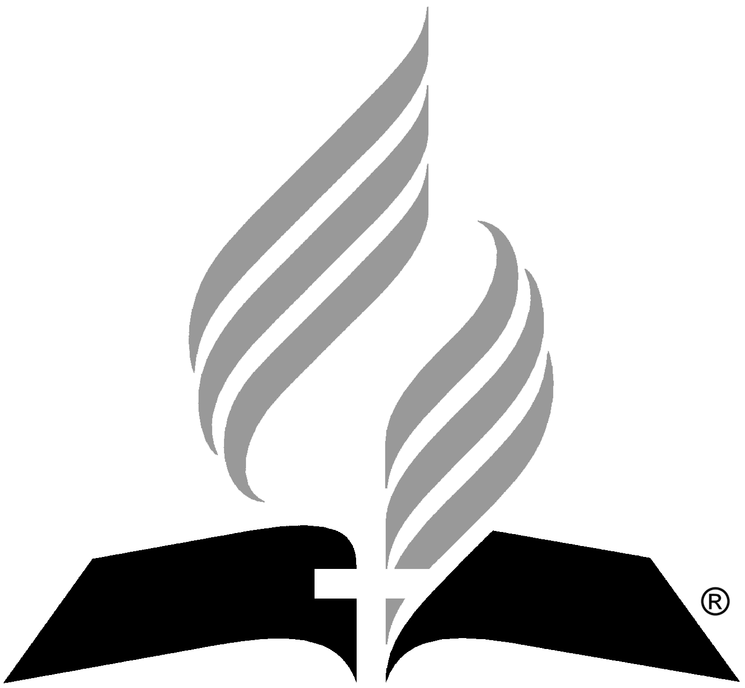

Southeastern California Conference
of Seventh-day Adventists
As Of 1/23/2023

Jacquelyn Brooks MSW, LCSW
Licensed Clinical Social worker specialized in, cognitive behavioral therapy, solution-focused, client-centered & narrative therapies. Also integrates expressive therapy
Contact email:
jbrooks@discoveringhopellc.net 661.916.4549
Therapy is conducted virtually.

Citrus Counseling Services
Shaon Martineau, Associate Marriage and Family Therapy
  - Adults
  - Couples
David Davamony, Licensed Clinical Psychologist, LP
  - Adults
  - Parent-Child issues
  - Pastor-Congregational issues
Kari Hidalgo, Licensed Marriage and Family Therapy, LMFT
  - Adults
  - Parent-Child issues
  - Adolescents
Tiahna Frankian, LMFT
  - Adults
  - Parent-Child issues
  - Adolescents

Citrus Counseling Services
(previously known as Christian Counseling Center)
101 E. Redlands Blvd., #215
Redlands, CA 92373
(909) 793-1078
info@christiancounselingservice.org
Erin Mancha, LMFT
  - Adults and Trauma
  - Parent-Child issues
  - Adolescents
Ashley Mann, LMFT
  - Parent-Child issues
  - Adolescents
Megan Pedroza, LMFT
  - Parent-Child issues
  - Child Therapy
Steve Brown, Licensed Clinical Psychologist
  - Adults
  - Pastor-Congregational issues
  - Mental illnesses
Laura Puerto, LMFT
  - Adults
  - Parent-Child issues
  - Pastor-Congregational issues

Justin Marmion, LPCC
  - Adults-Trauma
  - Adolescents

Updated 06/19/2023

